Exercise 1: Configuring a Basic Spring Application
Scenario:
Your company is developing a web application for managing a library. You need to use the Spring Framework to handle the backend operations.
Steps:
- Set Up a Spring Project:
  - Create a Maven project named LibraryManagement.
  - Add Spring Core dependencies in the pom.xml file.
Spring Dependencies:

<dependencies>
<dependency>
<groupId>org.springframework.boot</groupId>
<artifactId>spring-boot-starter-data-jpa</artifactId>
</dependency>
<dependency>
<groupId>org.springframework.boot</groupId>
<artifactId>spring-boot-starter-web</artifactId>
</dependency>

<dependency>
<groupId>org.springframework.boot</groupId>
<artifactId>spring-boot-devtools</artifactId>
<scope>runtime</scope>
<optional>true</optional>
</dependency>
<dependency>
<groupId>org.springframework.boot</groupId>
<artifactId>spring-boot-starter-test</artifactId>
<scope>test</scope>
</dependency>
</dependencies>

- Configure the Application Context:
  - Create an XML configuration file named applicationContext.xml in the src/main/resources directory.
  - Define beans for BookService and BookRepository in the XML file.

applicationContext.xml:

<?xml version="1.0" encoding="UTF-8"?>
<beans xmlns="http://www.springframework.org/schema/beans"
xmlns:xsi="http://www.w3.org/2001/XMLSchema-instance"
xsi:schemaLocation="http://www.springframework.org/schema/beans
https://www.springframework.org/schema/beans/spring-beans.xsd">

<bean id="bookRepository" class="com.library.repository.BookRepository"/>

<bean id="bookService" class="com.library.service.BookService">
<property name="bookRepository" ref="bookRepository"/>
</bean>

</beans>

- Define Service and Repository Classes:
  - Create a package com.library.service and add a class BookService.
  - Create a package com.library.repository and add a class BookRepository.

BookService.java:
package com.library.service;
import com.library.repository.BookRepository;
public class BookService {
private BookRepository bookRepository;
public void setBookRepository(BookRepository bookRepository) {
this.bookRepository = bookRepository;
}
public void displayBooks() {
System.out.println("Display Books Method");
bookRepository.listBooks();
}
}
BookRepository.java:
package com.library.repository;
public class BookRepository {
public void listBooks() {
System.out.println("Books from BookRepository.");
}

}

- Run the Application:
  - Create a main class to load the Spring context and test the configuration.
LibraryManagementApplication.java:
package com.library;
import org.springframework.boot.SpringApplication;
import com.library.service.BookService;
import org.springframework.context.ApplicationContext;
import org.springframework.context.support.ClassPathXmlApplicationContext;
public class LibraryManagementApplication {
public static void main(String[] args) {
ApplicationContext context = new ClassPathXmlApplicationContext("applicationContext.xml");
BookService service = (BookService) context.getBean("bookService");
service.displayBooks();
}
}

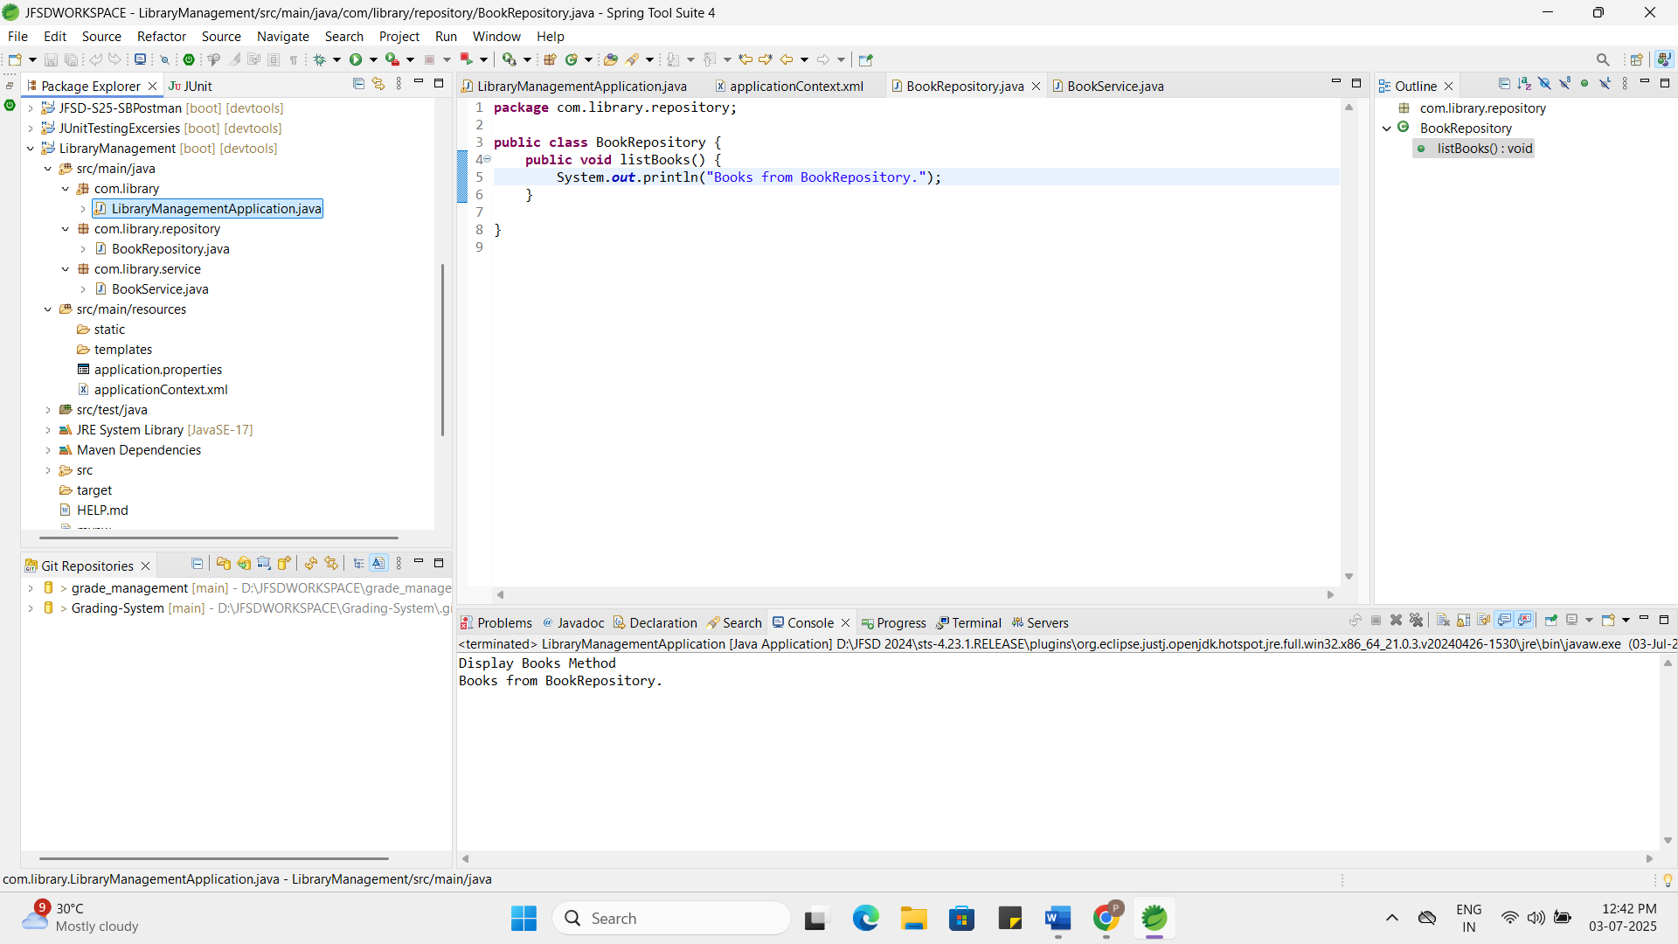

Exercise 2: Implementing Dependency Injection
Scenario:
In the library management application, you need to manage the dependencies between the BookService and BookRepository classes using Spring's IoC and DI.
Steps:
- Modify the XML Configuration:
  - Update applicationContext.xml to wire BookRepository into BookService.
applicationContext.xml:
<?xml version="1.0" encoding="UTF-8"?>
<beans xmlns="http://www.springframework.org/schema/beans"
xmlns:xsi="http://www.w3.org/2001/XMLSchema-instance"
xsi:schemaLocation="http://www.springframework.org/schema/beans
https://www.springframework.org/schema/beans/spring-beans.xsd">
<bean id="bookRepository" class="com.library.repository.BookRepository"/>
<bean id="bookService" class="com.library.service.BookService">
<property name="bookRepository" ref="bookRepository"/>
</bean>
</beans>
- Update the BookService Class:
  - Ensure that BookService class has a setter method for BookRepository.
BookService.java:
package com.library.service;
import com.library.repository.BookRepository;
public class BookService {
private BookRepository bookRepository;
public void setBookRepository(BookRepository bookRepository) {
this.bookRepository = bookRepository;
}
public void displayBooks() {
System.out.println("BookService: Delegating to BookRepository");
bookRepository.listBooks();
}
}
- Test the Configuration:
  - Run the LibraryManagementApplication main class to verify the dependency injection.
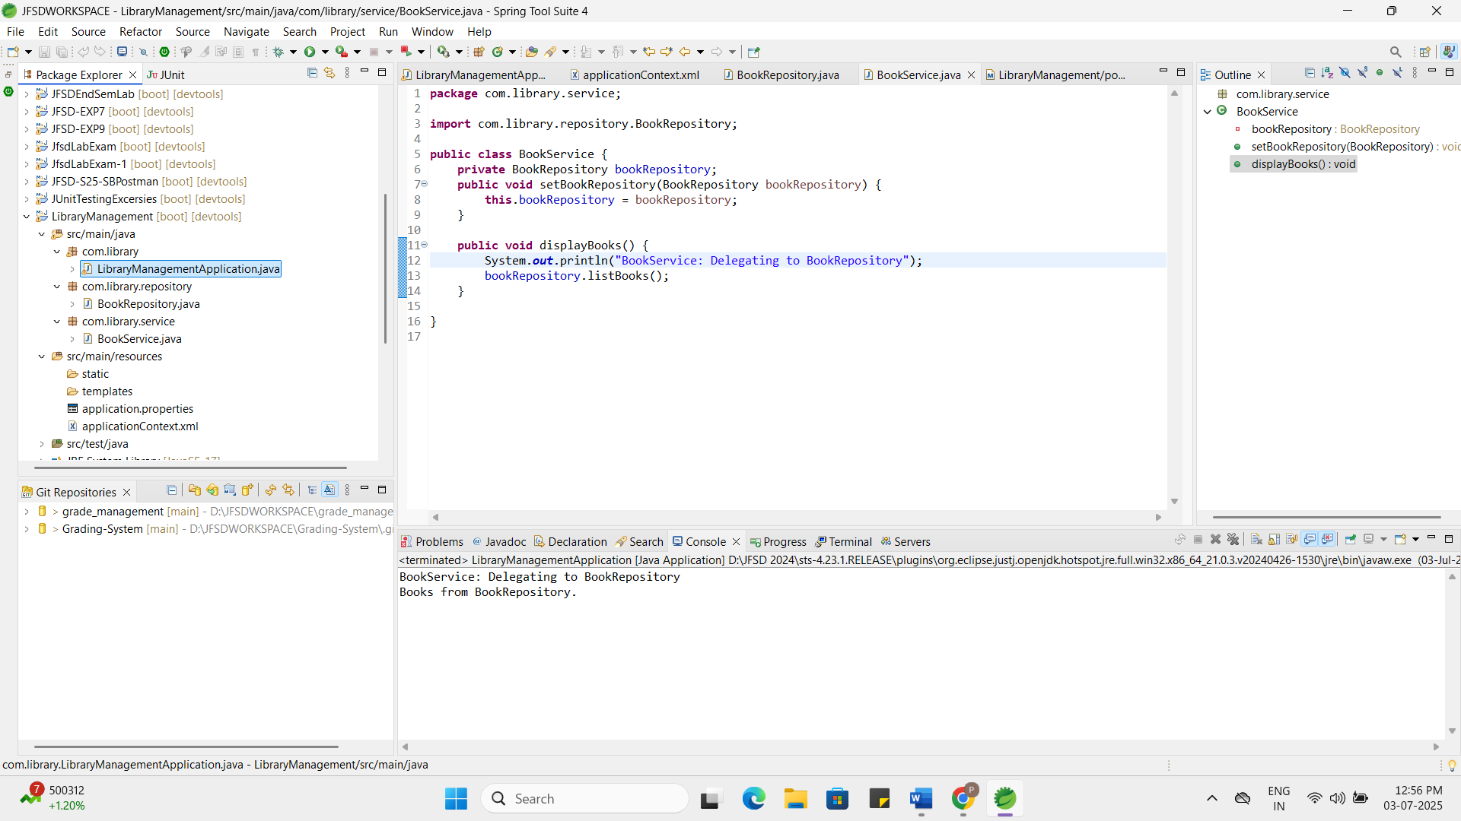

Exercise 3: Implementing Logging with Spring AOP
Scenario:
The library management application requires logging capabilities to track method execution times.
Steps:
- Add Spring AOP Dependency:
  - Update pom.xml to include Spring AOP dependency.

pom.xml:
Spring AOP dependency:
<dependency>
<groupId>org.springframework</groupId>
<artifactId>spring-aspects</artifactId>
<version>5.3.29</version>
</dependency>
<dependency>
<groupId>org.aspectj</groupId>
<artifactId>aspectjweaver</artifactId>
<version>1.9.20.1</version>
</dependency>
- Create an Aspect for Logging:
  - Create a package com.library.aspect and add a class LoggingAspect with a method to log execution times.
LoggingAspect.java:
package com.library.aspect;
import org.aspectj.lang.ProceedingJoinPoint;
import org.aspectj.lang.annotation.Around;
import org.aspectj.lang.annotation.Aspect;
@Aspect
public class LoggingAspect {
@Around("execution(* com.library.service.*.*(..))")
public Object logExecutionTime(ProceedingJoinPoint joinPoint) throws Throwable {
System.out.println("Starting method: " + joinPoint.getSignature());
long start = System.currentTimeMillis();
Object result = joinPoint.proceed();
long end = System.currentTimeMillis();
System.out.println("Completed: " + joinPoint.getSignature() + " in " + (end - start) + " ms");
return result;
}
}
- Enable AspectJ Support:
  - Update applicationContext.xml to enable AspectJ support and register the aspect.

applicationContext.xml:

<?xml version="1.0" encoding="UTF-8"?>
<beans xmlns="http://www.springframework.org/schema/beans"
xmlns:context="http://www.springframework.org/schema/context"
xmlns:aop="http://www.springframework.org/schema/aop"
xmlns:xsi="http://www.w3.org/2001/XMLSchema-instance"
xsi:schemaLocation="
http://www.springframework.org/schema/beans https://www.springframework.org/schema/beans/spring-beans.xsd
http://www.springframework.org/schema/context https://www.springframework.org/schema/context/spring-context.xsd
http://www.springframework.org/schema/aop https://www.springframework.org/schema/aop/spring-aop.xsd">
<context:component-scan base-package="com.library"/>
<aop:aspectj-autoproxy/>
<bean id="loggingAspect" class="com.library.aspect.LoggingAspect"/>
<bean id="bookRepository" class="com.library.repository.BookRepository"/>
<bean id="bookService" class="com.library.service.BookService">
<property name="bookRepository" ref="bookRepository"/>
</bean>
</beans>

- Test the Aspect:
  - Run the LibraryManagementApplication main class and observe the console for log messages indicating method execution times.
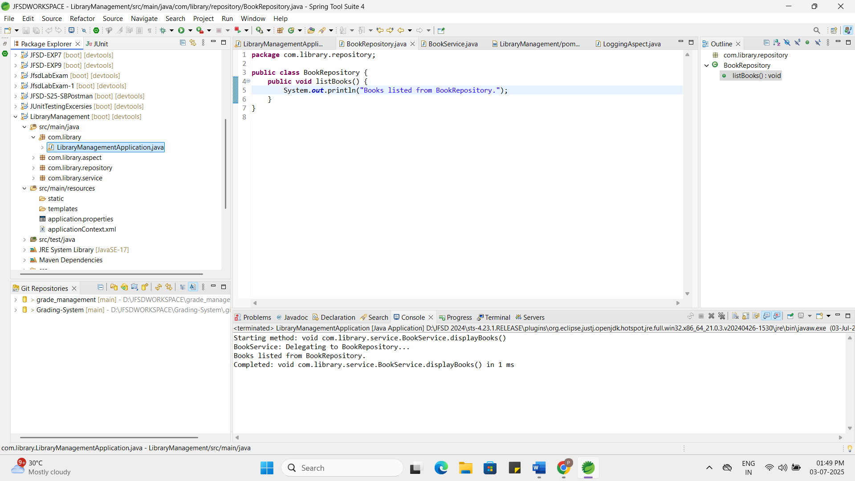

Exercise 4: Creating and Configuring a Maven Project
Scenario:
You need to set up a new Maven project for the library management application and add Spring dependencies.
Steps:
- Create a New Maven Project:
  - Create a new Maven project named LibraryManagement.
Created LibraryManagement Project
Updated the pom.xml
- Add Spring Dependencies in pom.xml:
  - Include dependencies for Spring Context, Spring AOP, and Spring WebMVC.
Added the dependencies regarding the spring AOP, spring web MVC in pom.xml

- Configure Maven Plugins:
  - Configure the Maven Compiler Plugin for Java version 1.8 in the pom.xml file.
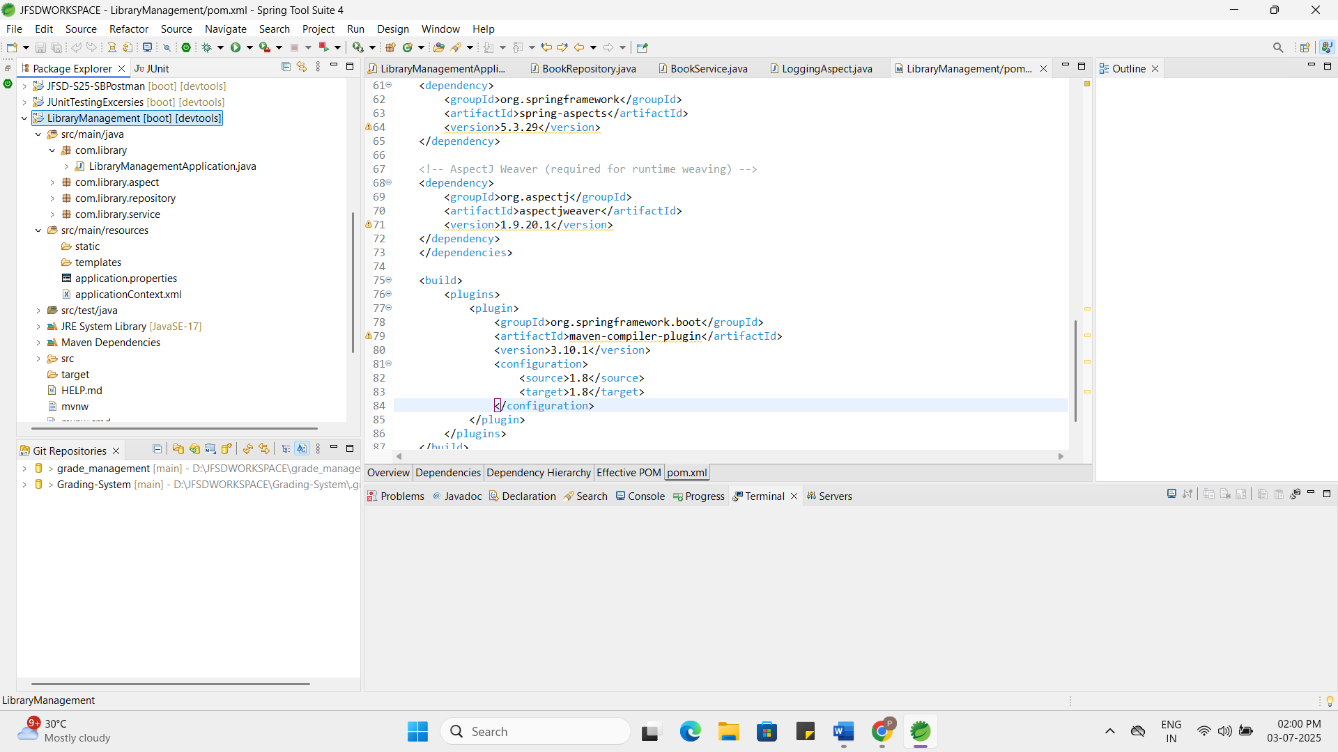
Exercise 5: Configuring the Spring IoC Container
Scenario:
The library management application requires a central configuration for beans and dependencies.
Steps:
- Create Spring Configuration File:
  - Create an XML configuration file named applicationContext.xml in the src/main/resources directory.
  - Define beans for BookService and BookRepository in the XML file.
applicationContext.xml:

<?xml version="1.0" encoding="UTF-8"?>
<beans xmlns="http://www.springframework.org/schema/beans"
xmlns:xsi="http://www.w3.org/2001/XMLSchema-instance"
xsi:schemaLocation="http://www.springframework.org/schema/beans
https://www.springframework.org/schema/beans/spring-beans.xsd">

<bean id="bookRepository" class="com.library.repository.BookRepository"/>

<bean id="bookService" class="com.library.service.BookService">
<property name="bookRepository" ref="bookRepository"/>
</bean>

</beans>

- Update the BookService Class:
  - Ensure that the BookService class has a setter method for BookRepository.
- Run the Application:
  - Create a main class to load the Spring context and test the configuration.


Exercise 6: Configuring Beans with Annotations
Scenario:
You need to simplify the configuration of beans in the library management application using annotations.
Steps:
- Enable Component Scanning:
  - Update applicationContext.xml to include component scanning for the com.library package.
applicationContext.xml:
<?xml version="1.0" encoding="UTF-8"?>
<beans xmlns="http://www.springframework.org/schema/beans"
xmlns:context="http://www.springframework.org/schema/context"
xmlns:xsi="http://www.w3.org/2001/XMLSchema-instance"
xsi:schemaLocation="
http://www.springframework.org/schema/beans https://www.springframework.org/schema/beans/spring-beans.xsd
http://www.springframework.org/schema/context https://www.springframework.org/schema/context/spring-context.xsd">
<context:component-scan base-package="com.library"/>
</beans>
- Annotate Classes:
  - Use @Service annotation for the BookService class.
  - Use @Repository annotation for the BookRepository class.
BookService.java:
package com.library.service;
import com.library.repository.BookRepository;
import org.springframework.beans.factory.annotation.Autowired;
import org.springframework.stereotype.Service;
@Service
public class BookService {
@Autowired
private BookRepository bookRepository;
public void setBookRepository(BookRepository bookRepository) {
this.bookRepository = bookRepository;
}
public void displayBooks() {
System.out.println("Book Service - @Autowired");
bookRepository.listBooks();
}
}
BookRepository.java:
package com.library.repository;
import org.springframework.stereotype.Repository;
@Repository
public class BookRepository {
public void listBooks() {
System.out.println("Book Repository - @Repository");
}
}
- Test the Configuration:
  - Run the LibraryManagementApplication main class to verify the annotation-based configuration.
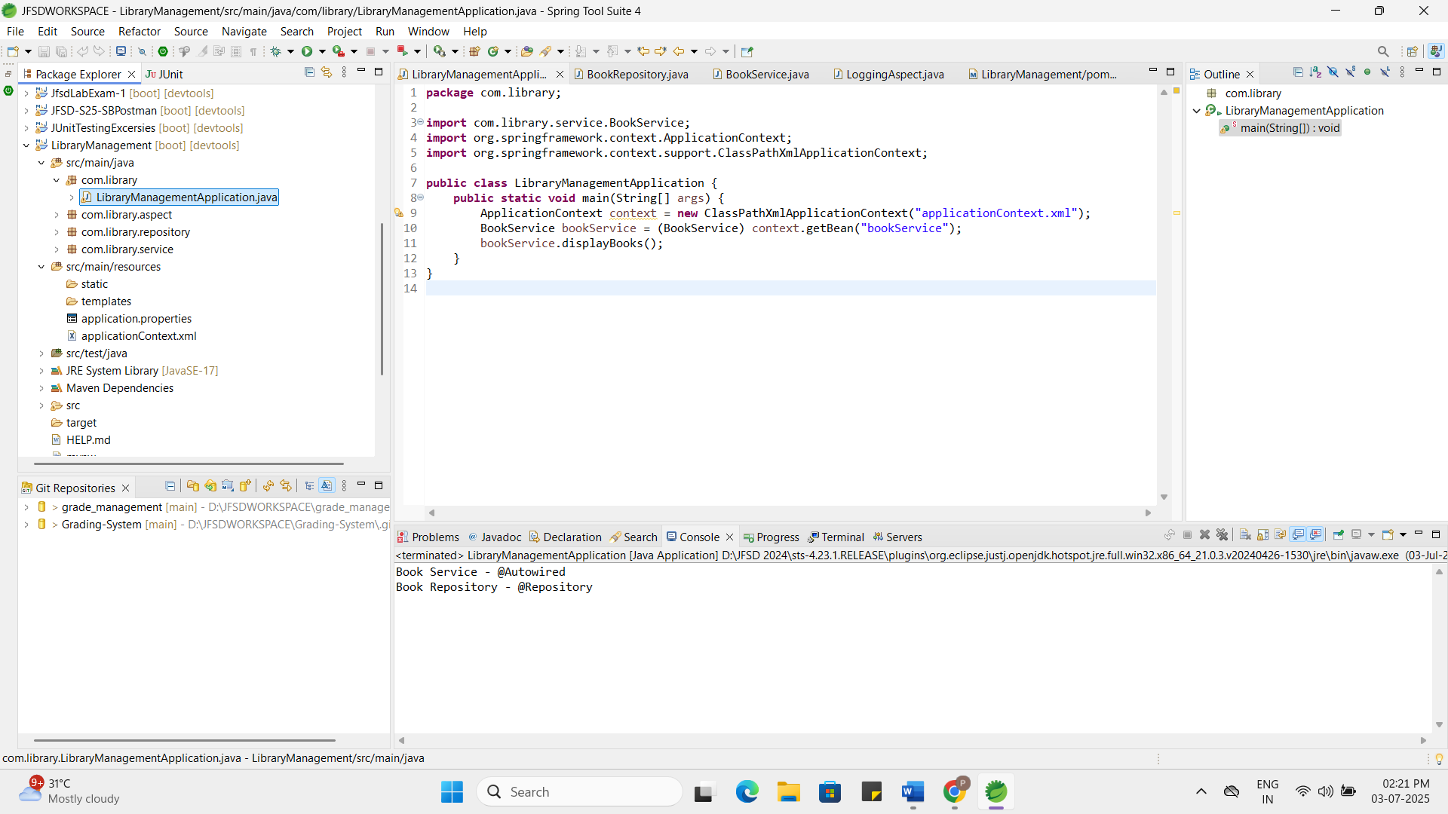

Exercise 7: Implementing Constructor and Setter Injection
Scenario:
The library management application requires both constructor and setter injection for better control over bean initialization.
Steps:
- Configure Constructor Injection:
  - Update applicationContext.xml to configure constructor injection for BookService.
applicationContext.xml:
<?xml version="1.0" encoding="UTF-8"?>
<beans xmlns="http://www.springframework.org/schema/beans"
xmlns:xsi="http://www.w3.org/2001/XMLSchema-instance"
xsi:schemaLocation="
http://www.springframework.org/schema/beans https://www.springframework.org/schema/beans/spring-beans.xsd">
<bean id="bookRepository" class="com.library.repository.BookRepository"/>
<bean id="bookService" class="com.library.service.BookService">
<constructor-arg value="Poornima"/>
<property name="bookRepository" ref="bookRepository"/>
</bean>
</beans>
- Configure Setter Injection:
  - Ensure that the BookService class has a setter method for BookRepository and configure it in applicationContext.xml.
BookService.java:
package com.library.service;
import com.library.repository.BookRepository;
public class BookService {
private BookRepository bookRepository;
private String librarian;
public BookService(String librarian) {
this.librarian = librarian;
}
public void setBookRepository(BookRepository bookRepository) {
this.bookRepository = bookRepository;
}
public void displayBooks() {
System.out.println("Librarian: " + librarian);
System.out.println("BookService: Delegating to BookRepository");
bookRepository.listBooks();
}
}
BookRepository.java:
package com.library.repository;
import org.springframework.stereotype.Repository;
@Repository
public class BookRepository {
public void listBooks() {
System.out.println("Book Repository");
}
}
- Test the Injection:
  - Run the LibraryManagementApplication main class to verify both constructor and setter injection.
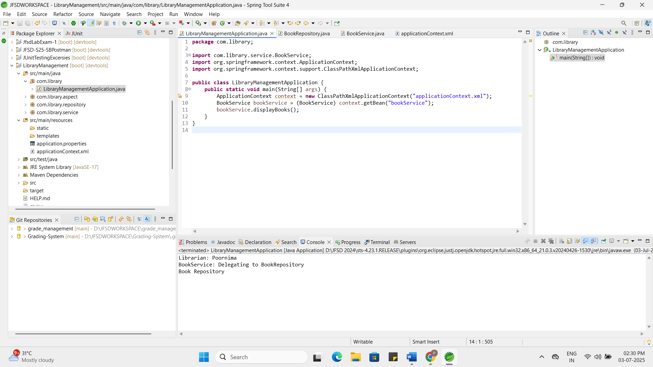

Exercise 8: Implementing Basic AOP with Spring
Scenario:
The library management application requires basic AOP functionality to separate cross-cutting concerns like logging and transaction management.
Steps:
- Define an Aspect:
  - Create a package com.library.aspect and add a class LoggingAspect.
Answer:
Logging Aspect java class is added in the com.library.aspect package in Library Management.
- Create Advice Methods:
  - Define advice methods in LoggingAspect for logging before and after method execution.
LoggingAspect:
package com.library.aspect;
import org.aspectj.lang.annotation.After;
import org.aspectj.lang.annotation.Aspect;
import org.aspectj.lang.annotation.Before;
import org.springframework.stereotype.Component;
@Aspect
@Component
public class LoggingAspect {
@Before("execution(* com.library.service.BookService.displayBooks(..))")
public void beforeDisplayBooks() {
System.out.println("Before Book Service called");
}
@After("execution(* com.library.service.BookService.displayBooks(..))")
public void afterDisplayBooks() {
System.out.println("After Book Service called");
}
}
- Configure the Aspect:
  - Update applicationContext.xml to register the aspect and enable AspectJ auto-proxying.
applicationContext.xml:
<?xml version="1.0" encoding="UTF-8"?>
<beans xmlns="http://www.springframework.org/schema/beans"
xmlns:context="http://www.springframework.org/schema/context"
xmlns:aop="http://www.springframework.org/schema/aop"
xmlns:xsi="http://www.w3.org/2001/XMLSchema-instance"
xsi:schemaLocation="
http://www.springframework.org/schema/beans https://www.springframework.org/schema/beans/spring-beans.xsd
http://www.springframework.org/schema/context https://www.springframework.org/schema/context/spring-context.xsd
http://www.springframework.org/schema/aop https://www.springframework.org/schema/aop/spring-aop.xsd">
<context:component-scan base-package="com.library"/>

<aop:aspectj-autoproxy/>
</beans>
- Test the Aspect:
  - Run the LibraryManagementApplication main class to verify the AOP functionality.
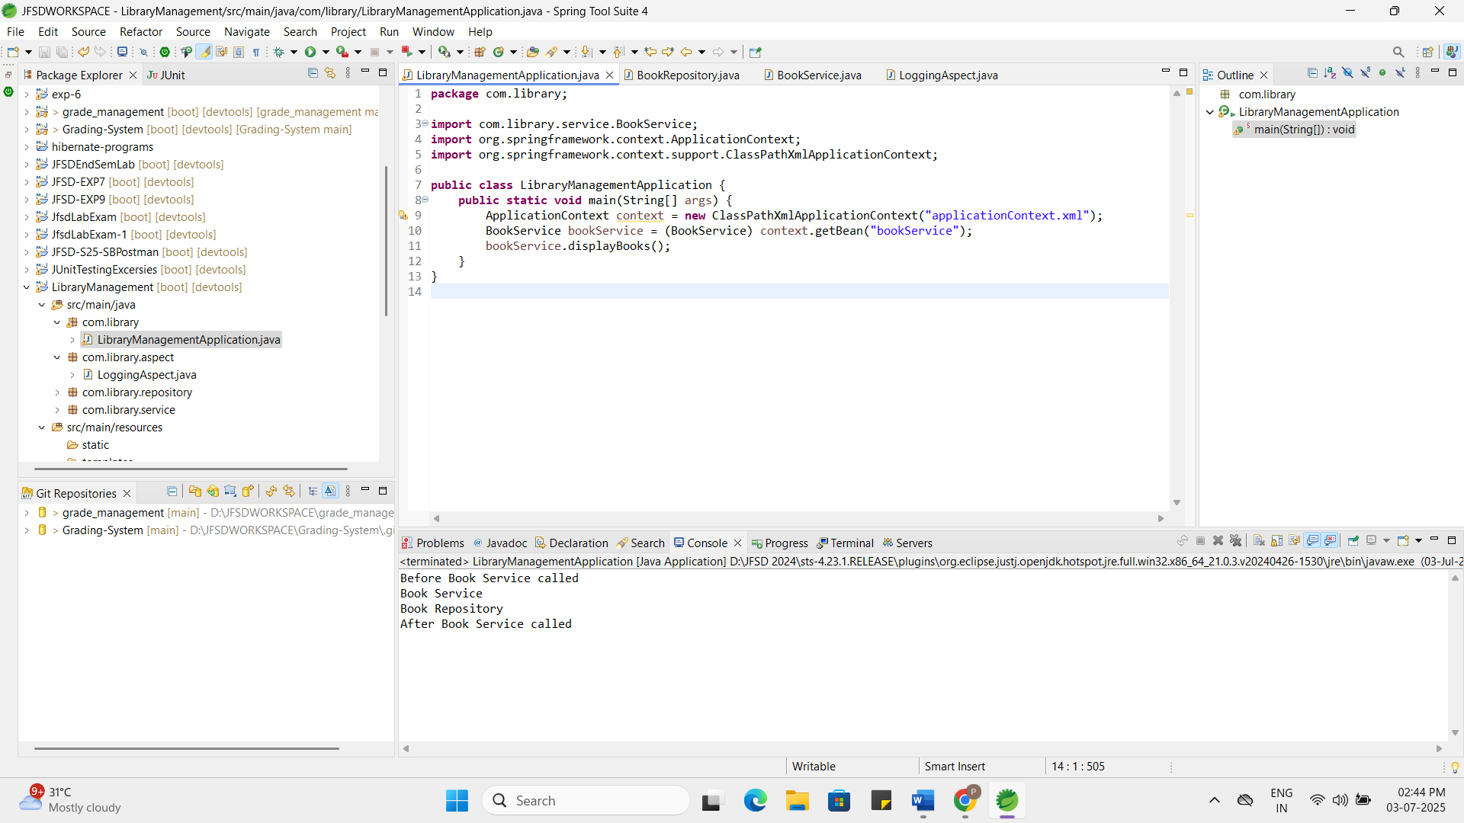

Exercise 9: Creating a Spring Boot Application
Scenario:
You need to create a Spring Boot application for the library management system to simplify configuration and deployment.
Steps:
- Create a Spring Boot Project:
  - Use Spring Initializr to create a new Spring Boot project named LibraryManagement.
- Add Dependencies:
  - Include dependencies for Spring Web, Spring Data JPA, and H2 Database.
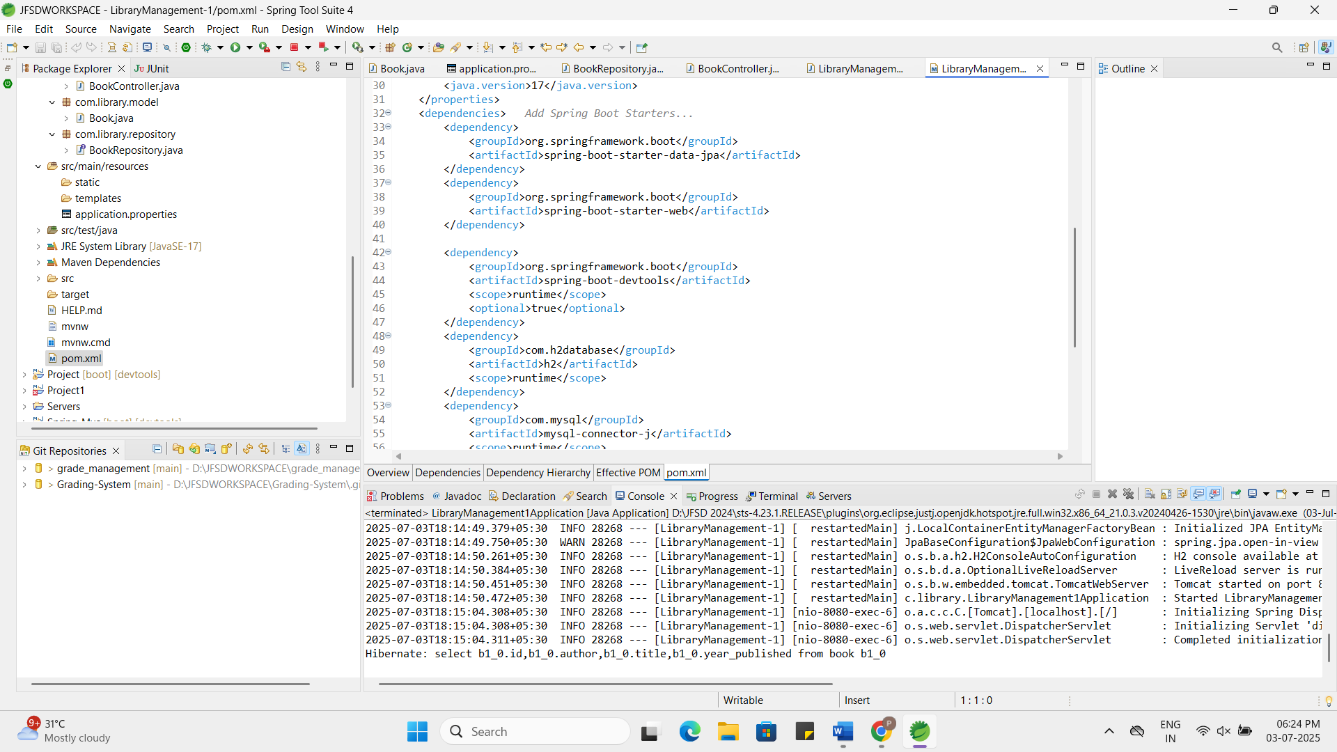
- Create Application Properties:
  - Configure database connection properties in application.properties.
application.properties:
spring.application.name=LibraryManagement-1
# H2 Console
spring.h2.console.enabled=true
spring.h2.console.path=/h2-console
# JPA Configuration
spring.datasource.url=jdbc:h2:mem:librarydb
spring.datasource.driver-class-name=org.h2.Driver
spring.datasource.username=root
spring.datasource.password=admin
spring.jpa.show-sql=true
spring.jpa.hibernate.ddl-auto=update
spring.jpa.properties.hibernate.dialect=org.hibernate.dialect.H2Dialect

- Define Entities and Repositories:
  - Create Book entity and BookRepository interface.
Book.java:
package com.library.model;
import jakarta.persistence.*;
@Entity
public class Book {
@Id
@GeneratedValue(strategy = GenerationType.IDENTITY)
private Long id;
private String title;
private String author;
private int yearPublished;
public Book() {
}
public Book(String title, String author, int yearPublished) {
this.title = title;
this.author = author;
this.yearPublished = yearPublished;
}
public Long getId() {
return id;
}
public void setId(Long id) {
this.id = id;
}
public String getTitle() {
return title;
}

public void setTitle(String title) {
this.title = title;
}
public String getAuthor() {
return author;
}
public void setAuthor(String author) {
this.author = author;
}
public int getYearPublished() {
return yearPublished;
}
public void setYearPublished(int yearPublished) {
this.yearPublished = yearPublished;
}
}
BookRepository.java:
package com.library.repository;
import com.library.model.Book;
import org.springframework.data.jpa.repository.JpaRepository;
public interface BookRepository extends JpaRepository<Book, Long> {
}
- Create a REST Controller:
  - Create a BookController class to handle CRUD operations.
BookController.java:
package com.library.controller;
import com.library.model.Book;
import com.library.repository.BookRepository;
import org.springframework.beans.factory.annotation.Autowired;
import org.springframework.web.bind.annotation.*;
import java.util.List;
import java.util.Optional;
@RestController
@RequestMapping("/api/books")
public class BookController {
@Autowired
private BookRepository bookRepository;
@GetMapping
public List<Book> getAllBooks() {
return bookRepository.findAll();
}
@GetMapping("/{id}")
public Book getBookById(@PathVariable Long id) {
Optional<Book> book = bookRepository.findById(id);
return book.orElse(null);
}
@PostMapping
public Book addBook(@RequestBody Book book) {
return bookRepository.save(book);
}
@PutMapping("/{id}")
public Book updateBook(@PathVariable Long id, @RequestBody Book updatedBook) {
return bookRepository.findById(id).map(book -> {
book.setTitle(updatedBook.getTitle());
book.setAuthor(updatedBook.getAuthor());
book.setYearPublished(updatedBook.getYearPublished());
return bookRepository.save(book);
}).orElse(null);
}
@DeleteMapping("/{id}")
public String deleteBook(@PathVariable Long id) {
bookRepository.deleteById(id);
return "Book deleted successfully";
}
}
- Run the Application:
  - Run the Spring Boot application and test the REST endpoints.
